

**DEPARTMENT OF**

**ELECTRICAL AND ELECTRONICS ENGINEERING**

**EEM 466 High Voltage Techniques**

**Spring 2020-2021**

**1st Report**

|  |  |  |  |  |
| --- | --- | --- | --- | --- |
| **Date:** | | | **01 April 2021** | |
| **Homework Subject:** | | | |  | | --- | | Examination of conduction and breakdown concepts in liquid dielectrics (theories, processes and applications) | | |
| **Homework Number:** | | | **Group 2** | |
| **Partners:** |  | **Number** | **Name - Surname** | **GRADE** |
| 1- | **12913007014** | **Cansu CEYLAN** |  |
| 2- | **13005077946** | **Anıl ANT** |  |

**Abstract:**

As a result of the increasing demand for electrical energy in today's world the need for power equipment is also increasing. The need for liquid dielectric materials is increasing at the same rate to reduce losses and malfunctions in power equipment. Insulation in terms of continuity, safety and economic operation of high voltage facilities level is very important. In this research study, we mentioned the importance, conduction and failures of liquid dielectrics in high voltage applications. When the usage areas of liquid dielectrics are examined, we talked about the vital importance of important equipment like transformers that enable electricity to be produced and delivered to us.

**Introduction:**

Insulation works of high voltage devices, energy continuity, safety and economy are important issues in terms of. Insulating liquids transformers, breakers, capacitors, reactors, cables, bushings, To provide cooling and electrical insulation in high voltage equipment such as is used. Temperature inside these equipment rise causes losses. For this reason, the generated heat must be distributed reliably and economically. The poor performance of the oil used causes electrical failures. These faults play a vital role especially for transformers. Disruptions in electricity generation and distribution significantly affect human life. For this reason, testing and analysis of liquid dielectric materials are very important. Thermal cooling capability, durability, efficiency, price, environment features such as its friendliness are taken into account.

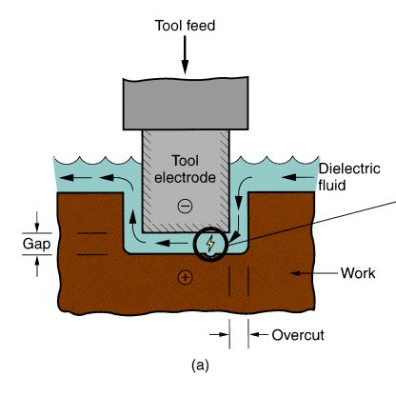

**Figure 1:** Electro erosion

The deterioration of liquid dielectrics is generally caused by some reasons consisting of ions, solid particles, gases and environmental factors that remain in the liquid as a result of excessive current. If not corrected, it causes permanent problems in the devices. (Overheating, disruption of the device, dangerous arc formation etc.) Therefore, regular fluid maintenance and the use of quality dielectrics are very important for human life and the environment. Also, the role of liquid dielectrics is critical in these areas where very high voltages are present.

**1)Dielectric Materials:**

Dielectric materials are known as electrical insulators. They are used to prevent the flow of electricity, thus they act like an insulator. Another task is to store electrical charge or increase capacitance.

The word dielectric consists of the words dia and electricity. Dia is a prefix that means "between" in Greek. This means that it is placed between conductive materials such as a non-conductive bridge. Since electrons are strongly bound to the nucleus in dielectrics, free electrons cannot travel, which prevents them from conducting electricity. Dielectrics have very few electrons for their conductivity and therefore have dipoles.

If an electric field is applied to a dielectric material, the negative and positively charged particles are separated in opposite directions and an electric dipole is produced, this phenomenon is dielectric polarization.

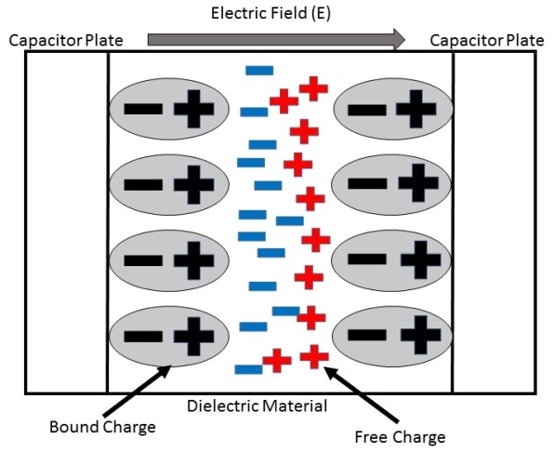

**Figure 1.1:** Dielectric polarization

In electromagnetism, the insulating constant or dielectric constant is the coefficient used to measure the ability of a material to store charge on it. In other words, the insulating constant is a measure of the effects of an electrical field or how it is affected by an insulating medium. The insulating constant of a medium is how much the electric field (more precisely flux) is formed per unit charge in the medium. The dielectric coefficient (dielectric constant) can also be defined as the ratio of the permeability of the medium to the permeability of the free space.

Permeability is the quality that describes the effect of a material on an electric field. The higher the permeability, the more the material tends to reduce the area created in that area. Materials with high dielectric constant have a strong ability to be polarized. If the polarization developed by applying an electric field is high for a dielectric material, the dielectric constant will also be high Materials with high dielectric constant also have high resistance.

ε = εr .ε0 = (1+χe).ε0

χe : its electrical susceptibility is dimensionless.

εr : relative insulating constant of any material

ε0 : is the vacuum insulation constant and its value is 8,854187817.. × 10−12 F/m

Difference between dielectric and insulator;

The material that stores electrical energy in the electric field is called a dielectric material, while the material that prevents the flow of electrons is called an insulator. The feature that distinguishes dielectric materials from insulators is that they can be used to store electricity.

**1.2) Application Areas of Dielectrics**

* The dielectric constant is used in materials processing, electronics and biomedical engineering.
* One of the usage areas of dielectrics is capacitors, they provide the storage of electrical charge.
* It can filter the noise caused by the signal in the resonant circuit.
* In electrical frequency switching operations the higher the frequency, the lower the dielectric constant should be used.
* Heat from dielectric losses can be used in microwave ovens
* Some of the usage areas of dielectric constant are as follows; semiconductors, rectifiers, transistors

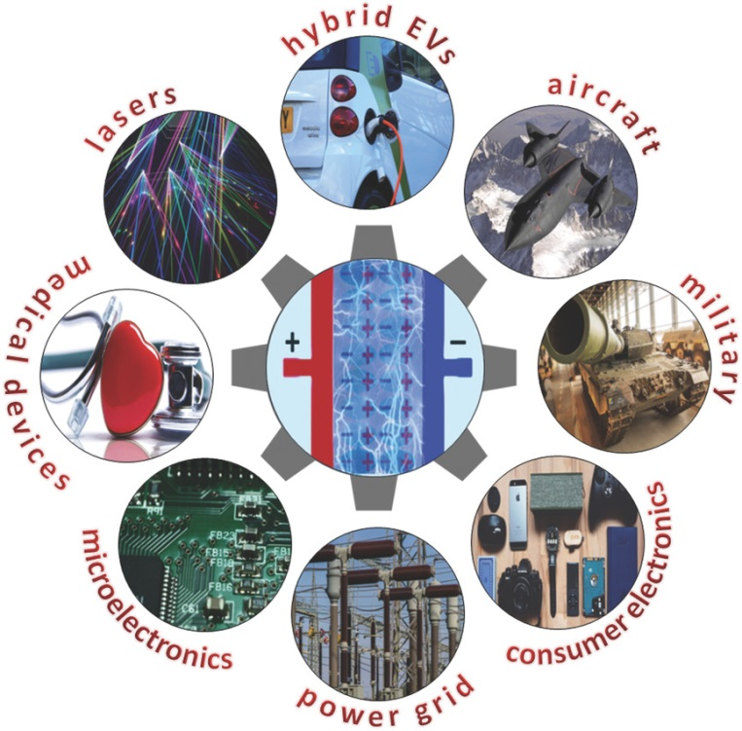

**Fıgure 1.2:** Application areas

**2) Classification of Dielectric Substances:**

**2.1) Solid and Composite**

Most dielectric materials are solid. A few sample of solid dielectric materials are mica, glass, plastic. Capacitors contain solid dielectrics which are mica, barium titanate,ceramic. The breakdown strength of solid dielectrics is higher compared to liquids and gases.

The need for a different insulation environment and equipment in high voltage applications, has brought various dielectric materials together, and thus composite materials were obtained.

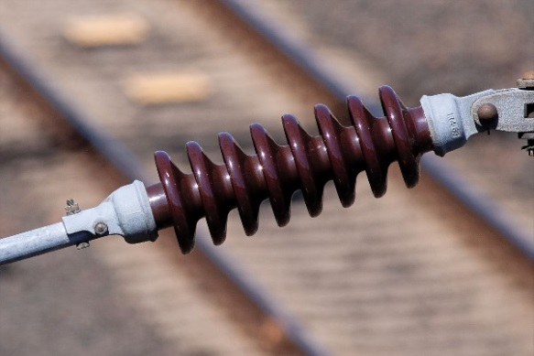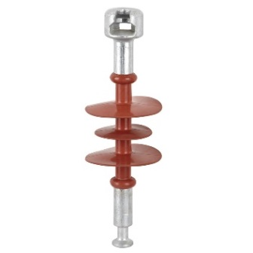 For example, solid and composite dielectric materials are used in the construction of insulators used to insulate energy lines in electrical transmission and distribution systems.

(a) (b)

**Figure 2.1:** Silicone Insulator **(a)** and Ceramic Insulator **(b)**

**2.2) Gas**

Gases, one of the three basic states of matter, consist of neutral molecules. Due to these natural properties, they offer an insulating environment, and their dielectric strength is very high. Examples of gas dielectrics are air, nitrogen, hydrogen and sulfur-hexafluoride (SF6). Dielectric gases are used for various purposes in high voltage applications and equipment such as electrical insulators, capacitors, transformers, etc.

For example, sulfur-hexafluoride (SF6) is a high dielectric strength and non-flammable gas. It is used in circuit breakers due to its heat absorption and arc extinguishing performance.

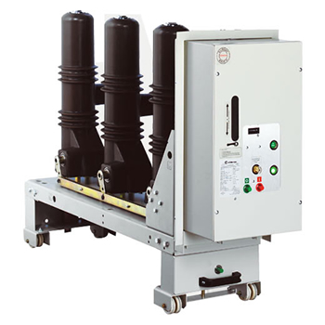

Fi**gure 2.2:** SF6 Circuit Breaker

**2.3) Liquid**

Dielectric liquids are used as electrical insulators in high voltage equipment such as transformers, capacitors and high voltage cables. The various dielectric liquids are used for different purposes such as providing electrical insulation, suppressing corona and arc, and cooling.

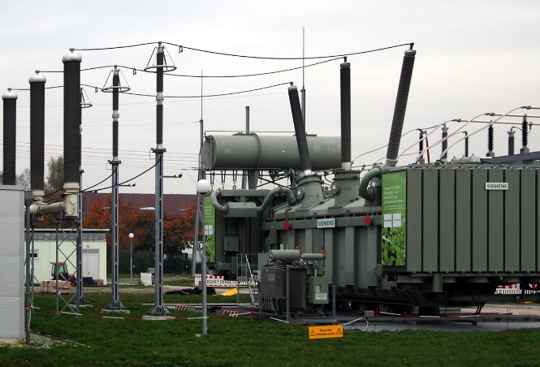 Liquids dielectric materials are classified into three types: mineral, synthetic and vegetable insulating oil. For example, mineral oil is the most frequently used liquid dielectric for about 80 years in order to prevent short circuit and pollution in transformers and to absorb the high heat generated in the transformer.

**Figure 2.3:** A 380 kV transformer with vegetable oil

**3) Liquid Dielectrics:**

Liquid dielectric is a dielectric material obtained by using liquid materials. Its primary task is to prevent or quickly eliminate / extinguish sudden discharges. Dielectric liquids are often used at high voltages. Examples of these are transformers, high voltage cables, capacitors, high voltage switching applications. its main task is to ensure electrical insulation, suppress sudden arcs and to perform cooling.

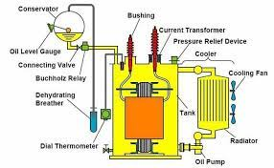

**Figure 3.1:** Transformer oil

Liquid dielectrics must have high strength, high thermal stability and good heat transfer properties against the building materials used. One of the advantages of liquid dielectrics is self-repair. In the event of a fault, the discharge channel does not leave a permanent conductive trace in the liquid.

Dissolved gases, dust, ionic impurities and moisture affect electrical materials. Electric discharge can cause conditions that degrade the performance of the dielectric.

Liquid dielectrics are used as electrical insulators in high voltage applications such as transformers, capacitors and high voltage cables and in key gears. Dielectric liquids have functions such as electrical insulation, suppressing corona and arc, and cooling.

|  |  |  |
| --- | --- | --- |
| **Mineral insulating oil** | Paraffinic oils  Naphthenic oils  Aromatic oils | Nonring long-chained structure  Saturated ring structure  Nonsaturated ring structure |
| **Synthetic**  **insulating oil** | Polyalphaolefins  Polyglycols  Synthetic ester oils | Manufactured by  polymerization of  hydrocarbon molecules  Produced by oxidation of  ethylene and propylene  Produced by reaction of acids  and alcohols with water |
| **Vegetable**  **insulating oil** | Soybean oil  Coconut oil  Cottonseed oil  Rapeseed oils | Vegetable oils are nontoxic,  biodegradable, low  inflammable, have a higher  breakdown voltage, high  flash point, high acidity  number, high viscosity and  pour point |

**Table 3.1 :** Classification of insulating liquids.

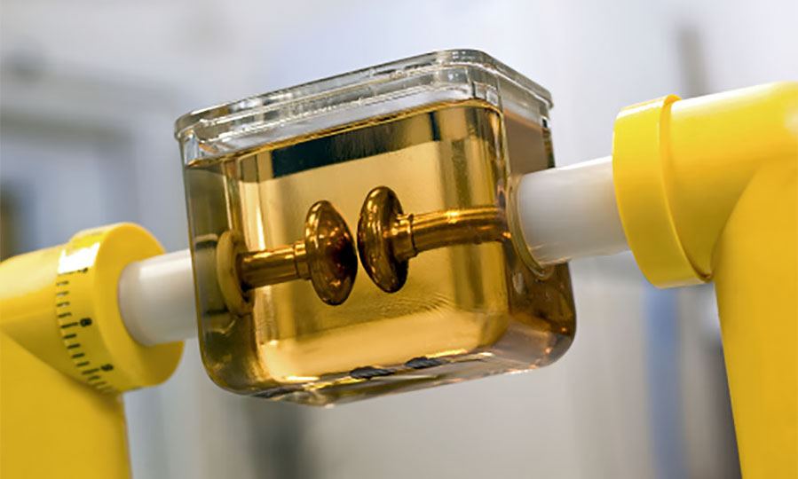 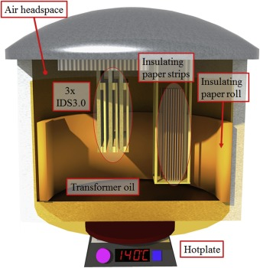

1. (b)

**Figure 3.2**: Vegatable oil(a) Dielectrometry sensor (IDS)

**4) Liquid Dielectric Types: Pure and Commercial**

**Pure liquids** can be expressed by definition as liquids that are structurally simple, homogeneous and very close to impurities that do not contain any solid, liquid and gaseous substances. The most commonly known liquids are paraffinic hydrocarbons, and their structures are like straight-chain. By testing pure liquids, conditions affecting conduction and breakdown can be better observed. For example, n-heptane  and n-hexane  are also pure liquid.

**Commercial liquids** are called impure liquids, which are composed of different organic liquids and are usually in the form of oils. Therefore, there are observations showing impurity such as gas bubbles, suspended particles in these liquids. Hence, it is difficult to separate and define these organic molecules experimentally.

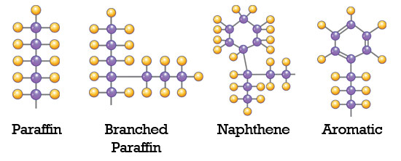 As a result, there are significant differences between pure liquids and commercial liquids in terms of both their structural and chemical properties and usage area.

**Figure 4.1:** Common Mineral Oil Molecules

Some tests are applied on insulating liquids before they are used in high voltage applications. In the test, the following factors need to observe :

* 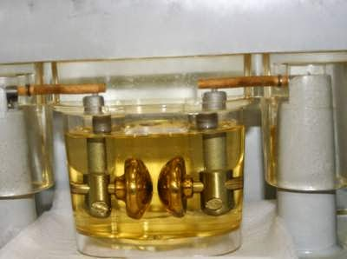Power factor liquid
* Acid number
* Visual test
* Breakdown voltage of dielectric
* Corrosive sulfur
* Specific resistance
* Interface tension

**Figure 4.2:** Mineral-oil Test

**5) Breakdown and Conduction in Pure Liquid Dielectrics**

In high temperature purified liquid dielectrics, deterioration can be controlled, but liquids are more prone to fouling. The contents of this impurity can be solids, other liquids in suspension and dissolved gases. Usually liquids due to their tendency to contaminate used with solids.Also, the liquid dielectric materials dissipate the heat in the device being used because it is a good heat transmitter.

**Purification**: The main impurities in liquid dielectrics are dust, moisture, dissolved gases and ionic. Various methods are used for the purification process, some of which are filtrations (mechanical filters, spray filters and electrostatic filters), centrifugation, degassing and distillation.

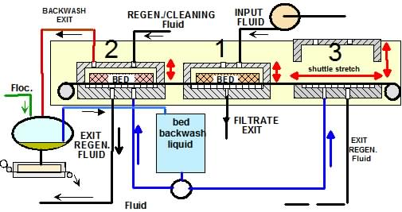

**Figure 5.1: Liquid purification**

Breakdown tests are done to test purity using small cells. It is made with a small amount of liquid and is an essential part of the purification process.

The electrodes used for fault voltage measurements are usually 0.5 to 1 spheres. The gaps between them are measured using a micrometer. The types of liquids, surface smoothness, the presence of oxide significantly affect the breaking strength.

These tests are usually done in the 50-100 kV range due to the small electrodes. Conductivities are 10 ~ 18 - when exposed to an electric field of less than 1 kV / cm. 10-20 mho / cm is obtained. These are most likely the result of impurities remaining after treatment. Also, when electric fields are high (> 100 kV / cm), currents increase rapidly and are subject to high fluctuations.

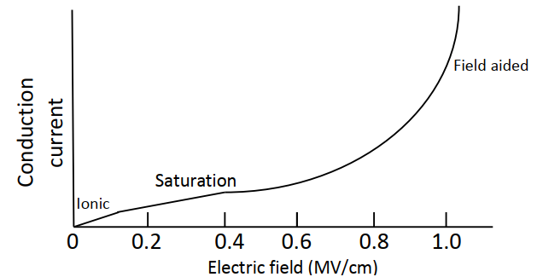

**Figure 5.2: The conduction current-electric field characteristic graph in a hydrocarbon liquid.**

In low electric fields, the current results from the dissociation of ions. (ionic region). It reaches saturation in the middle area (saturation) we see in the graph. If the area where the graph rises (field aided) The current obtained by the emission of electrons from the cathode is multiplied. liquid environment with Townsend mechanisms.

Breakdown voltage depends on the area, gap separation, and cathode operating capability and temperature. Additionally liquid viscosity, the temperature, density and molecular structure of the liquid are also factors affecting the breakdown of the liquid. If there are dissolved gases, the breakdown strength is higher. electronegative in character (like oxygen)

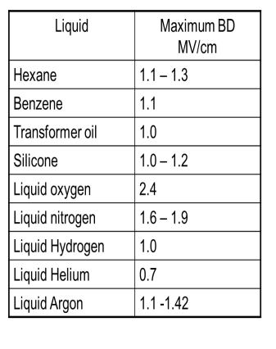

**Table 5.3 :** Liquid breakdown strength

**6) Breakdown and Conduction in Commercial Liquid Dielectrics**

As we know, commercial insulation liquids have impurity properties in terms of their structure. The clearest feature that indicates that they are not pure is that they have suspended particles and gas bubbles. This causes a decrease in the breakdown strength of the liquid.

When these commercial liquids are exposed to more than the maximum electric field they can withstand, i.e., when the dielectric strength is exceeded, this results in the formation of additional gases, increased bubbles and solid product formation in the liquid.

Naturally, there are factors affecting the breakdown situation in impure liquids. There are some different theories have been proposed in the literature to examine and analyse the breakdown in liquids.

1. Suspended Particle Mechanism
2. Cavitation and Bubble Mechanism
3. Thermal Mechanism
4. Stressed Oil Volume Mechanism

These theories and concepts will be examined in terms of the following situations.

**6.1)** **Breakdown Caused by Solid Particles**

Generally, commercial liquids contain solid particles of fibrous and dispersed nature. The permeability of these particles and the liquid they contain is not the same. Therefore, a force acts on solid particles as shown below.

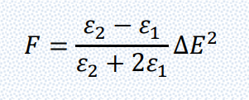





**Equation 6.1:** Force acting on particles

First of all, in this section, the particles are assumed as spherical which has a radius r. There are two situations in this section. The direction of the force is towards the higher area or lower area according to the value of the permeability of the particle and liquid.

If this particle is paper, the force will push the papers towards the higher area, and they will be lined up like a chain. This situation has the potential to trigger breakdown.

**6.2)** **Breakdown Caused by Gas Bubbles**

Gas bubbles may occur in impure liquids for some reason. Examples of these situations are changes in temperature of the environment and liquid pressure, also known as hydrostatic pressure. The force acting on the gas bubbles causes the bubbles to expand in the direction of the electric field. The force acting on the gas bubbles causes the bubbles to expand in the direction of the electric field. Finally, this bubble, which is formed as a result of expansion, may burst. The gas inside the bubble may be released, causing breakdown.

The important thing in this part is the breakdown strength of this gas which is inside the bubble and depend on the size of bubble. The formula (breakdown field)explaining this relationship is below :

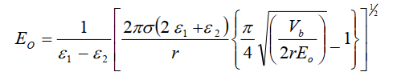

**Equation 6.2:** Breakdown Field

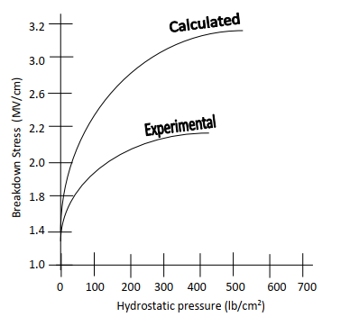

The breakdown field where the :









Since the first bubble is not assumed in this equation, theoretical results and experimental results are different from each other.

**Figure 6.1:** The graph of the breakdown

stress of n-hexane

**6.3)** **Breakdown Caused by Other Liquid**

If there is another amount of liquid in the insulating liquid (which is also called suspension), the breakdown can be occur.

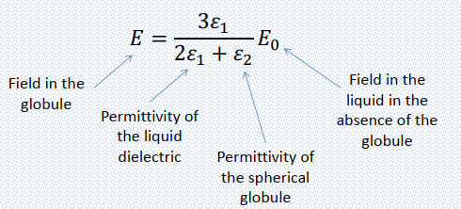

**Equation 6.3:** Globule Field

**Summary:**

In today's world, with the increasing need for electrical energy, the demand for transformers, capacitors, breakers, insulators and cables is also increasing. Every year, litres of insulating liquid are used for cooling and insulation purposes in these equipments which are used in electrical energy generation, transmission and distribution systems. It is very important that these equipment do not malfunction, operate efficiently and have a long life. For this purpose, the need for insulation liquids with different properties and structures is increasing. In this study report, dielectric materials and their usage areas, dielectric liquids and their types, breakdown and conduction concepts and theories are examined. One of the most important consequences is that the breakdown strength of the liquids used in insulation and cooling is significantly reduced by various factors and causes dangerous situations. At this point, the suitability and periodic maintenance of the insulating oil used in power systems is important. In addition, even though the use of dielectric liquids is very common, there are still many questions regarding breakdown and conduction issues on these liquids. Although we have theoretical knowledge about dielectric liquids, it is more difficult to do them experimentally due to reasons such as high voltage and current values and costly protective measures.

**References:**

**[1] Conduction And Breakdown Initiation In Dielectric Liquids Denat André CNRS And Grenoble University Grenoble Electrical Engineering Laboratory (G2E Lab) 25 Rues Des Martyrs, 38042 Grenoble, France**

**[2] Optıcal Study Of Conductıon And Breakdown In Dıelectrıc Lıquıds**

**Saburo Sakamoto, Hiroshi Yamada “IEEE Transactions On Electrical Insulation Vol. Eı-15 No.3, June 1980”**

**[3]A. Beroual, M. Zahn, A. Badent, K. Kist, A. J. Schwabe, H. Yamashita,**

**K. Yamazawa, M. Danikas, W. G. Chadband, and Y. Torshin, “Propagation**

**and structure of streamers in liquid dielectrics,” IEEE Elect. Insul.**

**Mag., vol. 14, no. 2, pp. 6–17, 1998.**

**[4]Theoretical Study Of The Initial Stage Of Sub-Nanosecond Pulsed Breakdown**

**İn Liquid Dielectrics M. N. Shneider, M. Pekker And A. Fridman” IEEE Transactions on Dielectrics and Electrical Insulation Vol. 19, No. 5; October 2012”**

**[5]Electrical İnsulating Liquid: A Review ;Deba Kumar Mahanta, Shakuntala Laskar “Journal Of Advanced Dıelectrıcs Vol. 7, No. 4 (2017) 1730001**